Multiple Choice Questions

1) | Replication of DNA in E. coli occurs in what type of fashion?

A) | unidirectional
B) | bidirectional
C) | multidirectional
D) | directionality can change depending upon specific conditions in the cell
E) | none of the above

Answer: B

Difficulty: 1 Topic: Early Insights into DNA Replication

2) | Which of the following is required for DNA polymerase I activity?

A) | 3′ hydroxyl group
B) | ATP, GTP, TTP and CTP
C) | Zn²⁺
D) | an RNA template
E) | all of the above

Answer: A

Difficulty: 2 Topic: DNA Polymerases

3) | Which of the following exonuclease activities is present in DNA polymerase I?

A) | 3′ exonuclease that degrades double stranded DNA
B) | 3′ exonuclease that degrades hairpin DNA
C) | 5′ exonuclease that degrades single stranded DNA
D) | 5′ exonuclease that removes RNA from a DNA-RNA duplex
E) | none of the above

Answer: D

Difficulty: 2 Topic: DNA Polymerases

4) | Which of the following was evidence that DNA polymerase I was not responsible for the bulk of DNA synthesis in vivo?

A) | the requirement for an RNA primer
B) | the presence of both polymerase and exonuclease activity in the same enzyme
C) | the number of enzyme copies in each cell far exceeded the number of replication forks
D) | the requirement for Mg²⁺
E) | none of the above

Answer: C

Difficulty: 2 Topic: DNA Polymerases

5) | A mutation in a gene results in a mutant phenotype. What occurs if the wild-type phenotype is restored by a mutation at another site in the gene?

A) | reversion
B) | silent mutation
C) | conjugation
D) | silent conjugation
E) | suppression

Answer: E

Difficulty: 2 Topic: A Brief Review of Microbial Genetics

6) | Which of the following DNA polymerases is correctly defined?

A) | polymerase I: DNA repair
B) | polymerase I: RNA primer excision
C) | polymerase II: DNA repair
D) | polymerase III: nucleotide incorporation during replication
E) | all of the above

Answer: E

Difficulty: 1 Topic: Multiple DNA Polymerases

7) | In the Klenow fragment of many DNA polymerases, the Mg²⁺ ions that are required for activity are coordinated to which amino acid R-groups?

A) | histidine and aspartate
B) | two aspartates
C) | aspartate and asparagine
D) | aspartate and glutamate
E) | glutamate and glutamine

Answer: B

Difficulty: 2 Topic: Multiple DNA Polymerases

8) | In DNA synthesis, the _____________ strand is synthesized in a __________ fashion.

A) | template; discontinuous
B) | template; continuous
C) | leading; discontinuous
D) | lagging; discontinuous
E) | none of the above

Answer: D

Difficulty: 1 Topic: Other Proteins at the Replication Fork

9) | Which of the following is the best description for primase?

A) | a DNA-dependent DNA polymerase
B) | an RNA-dependent DNA polymerase
C) | a DNA-dependent RNA polymerase
D) | an RNA-dependent RNA polymerase
E) | none of the above

Answer: C

Difficulty: 2 Topic: Other Proteins at the Replication Fork

10) | What is an Okazaki fragment?

A) | a small section of DNA bound to the leading strand
B) | a small section of DNA bound to the lagging strand
C) | a small section of RNA and DNA bound to the leading strand
D) | a small section of RNA and DNA bound to the lagging strand
E) | none of the above

Answer: D

Difficulty: 2 Topic: Other Proteins at the Replication Fork

11) | Which of the following describes the correct sequence of enzyme activity upon the lagging strand?

A) | primase, DNA ligase, DNA polymerase I, DNA polymerase III
B) | primase, DNA polymerase I, DNA polymerase III, DNA ligase
C) | DNA polymerase III, primase, DNA polymerase I, DNA ligase
D) | primase, DNA ligase, DNA polymerase III, DNA polymerase I
E) | primase, DNA polymerase III, DNA polymerase I, DNA ligase

Answer: E

Difficulty: 2 Topic: Other Proteins at the Replication Fork

12) | What enzyme that is part of the primosome is responsible for unwinding of the DNA ahead of the replication fork?

A) | topoisomerase
B) | helicase
C) | primase
D) | clamp loading complex
E) | single-stranded binding protein

Answer: B

Difficulty: 2 Topic: Other Proteins at the Replication Fork

13) | Which of the subunits of DNA polymerase III is responsible for the high processivity of the enzyme?

A) | β
B) | γ
C) | δ
D) | δ′
E) | ε

Answer: A

Difficulty: 2 Topic: Other Proteins at the Replication Fork

14) | How does the gp32 protein facilitate both stabilization of single-stranded DNA as well as its renaturation to double-stranded DNA?

A) | gp32 is an enzyme and thus its reaction of separating DNA strands is freely reversible
B) | gp32 binds only to regions of high A and T content so hydrogen bonding is reversible
C) | gp32 displays cooperativity in binding to single stranded DNA
D) | the gp32 C-terminal domain acts as a switch between weak and strong single stranded DNA binding
E) | none of the above

Answer: D

Difficulty: 3 Topic: Other Proteins at the Replication Fork

15) | Type I topoisomerases break _____ strand(s) of DNA; type II topoisomerases break _____strand(s) of DNA. DNA gyrase is a type ___ topoisomerase.

A) | both; 1; I
B) | both; 1; I
C) | both; 1; III
D) | 1; both; I
E) | 1; both; II

Answer: E

Difficulty: 2 Topic: Other Proteins at the Replication Fork

16) | In a type I topoisomerase, the active site amino acid _________ is covalently bound to the free _______ end of the cut in the DNA.

A) | serine; 3′
B) | serine; 5′
C) | tyrosine; 3′
D) | tyrosine; 5′
E) | none of the above

Answer: D

Difficulty: 2 Topic: Other Proteins at the Replication Fork

17) | Which of the following explains the result of type I topoisomerase activity on underwound DNA, considering that no energy (ATP) is used in the reaction?

A) | the linking number is decreased by 1
B) | the linking number is increased by 1
C) | the linking number remains the same but the twist decreases by 1
D) | the linking number remains the same but the twist increases by 1
E) | none of the above

Answer: B

Difficulty: 2 Topic: Other Proteins at the Replication Fork

18) | In eukaryotic replication, which polymerase is analogous to E. coli primase?

A) | pol α
B) | pol β
C) | pol γ
D) | pol δ
E) | pol ε

Answer: A

Difficulty: 2 Topic: Proteins in Eukaryotic DNA Replication

19) | What protein complexes with ATP and cardiolipin to initiate E. coli DNA replication by creating negative superhelical tension in the double stranded DNA?

A) | DnaA
B) | DnaB
C) | DnaC
D) | DnaJ
E) | DnaK

Answer: A

Difficulty: 2 Topic: Proteins in Eukaryotic DNA Replication

20) | Which of the following is an 11-base consensus sequence that makes up the autonomously replicating sequence present in yeast DNA that is a requirement for the start of replication?

A) | 5′-GTGCGTGCGTG-3′
B) | 5′-CCTCCTGGTGG-3′
C) | 5′-AAGCGCGCGCC-3′
D) | 5′-GGTGGACCTCC-3′
E) | 5′-TTTTATATTTT-3′

Answer: E

Difficulty: 2 Topic: Initiation of DNA Replication

21) | What feature of the telomerase enzyme allows it to synthesize DNA without the use of a DNA or RNA primer?

A) | it synthesizes new DNA in a 3′ to 5′ direction
B) | it contains an RNA oligonucleotide complementary to the telomeric sequence
C) | since the telomeric sequence is a 15 base repeat, it is synthesized separately from the replication process and merely sealed in place by the ligase action of telomerase
D) | telomeric DNA forms a hairpin that is used to create its own complimentary primer
E) | none of the above

Answer: B

Difficulty: 2 Topic: Replication of Linear Genomes

22) | The fact that the following molecule serves as a substrate for DNA polymerase in place of dTTP proves what issue with regard to DNA replication?

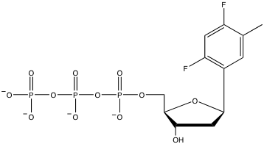

A) | DNA polymerase is highly error prone
B) | hydrogen bonding to N-3 of thymine is not critical for substrate recognition
C) | base stacking is the true driving force for nucleotide placement
D) | substrate shape might be as important as hydrogen bonding for DNA polymerase
E) | none of the above

Answer: D

Difficulty: 2 Topic: Fidelity of DNA Replication

Short Answer Questions

RNA primer based upon the following sequence

1) If a segment of a eukaryotic chromosome contained three origins of replication (at the sites indicated with arrows), how would the segment appear when replication was about half completed?

Answer:

Difficulty: 2 Topic: Early Insights into DNA Replication

2) For the following sequence, indicate the RNA primer that would be needed to start synthesis of the Okazaki fragment.

5’-A-A-C-T-A-G-A-C-C-A-G-A-3’

Answer:

3’-U-U-G-A-U-C-U-G-G-U-C-U-5’

Difficulty: 2 Topic: DNA Polymerases

3) Show the reaction (with arrow pushing) for addition of the next nucleotide:

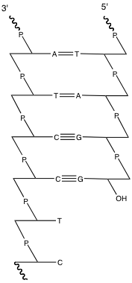

Answer:

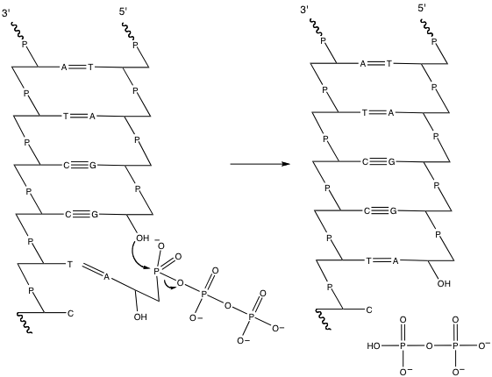

Difficulty: 2 Topic: DNA Polymerases

